**Cut Cake**

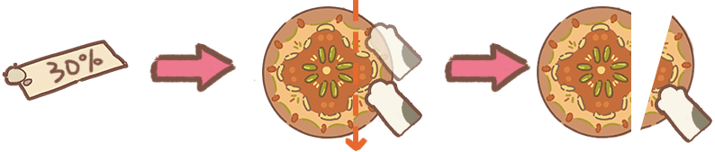

[Image from Animal Restaurant game]

Chef Gumi is the Chef of Animal Restaurant. Recently, he is interested in the mini-game Cut Cake. He is given a cake and he has to cut according to the customer’s request – the customer wants a part of the cake which is smaller than 50%. Please help Gumi check if he satisfies the request.

In the two-dimensional Cartesian coordinate system, the cake is a circle with its center point C and its radius while the cut is illustrated by a straight line from 2 different points – point A and point B.

**Input:**

The input consists of 8 float numbers. The first six numbers represent the x- and y-coordinates of points A, B, and C, respectively, $(-{10}^{5}≤x_{A},y_{A},x_{B},y_{B},x_{C},y_{C}≤{10}^{5})$. Next is the radius of the cake $(0<R≤{10}^{3})$ and last is the percentage of cake the customer wants $(0<P<50)$

**Output:**

Print YES if Gumi satisfies his customer’s request, means the difference between the smaller part of the cake and the request is within 5%. If not, print NO.

Sample test:

|  |  |
| --- | --- |
| Input 1 | Output 1 |
| -1 0 0 1 0 0 1 10 | YES |

|  |  |
| --- | --- |
| Input 2 | Output 2 |
| -1 0 0 1 0 0 1 15 | NO |